Purpose
The following information provides guidance for the evaluation of engineering programs. The guide outlines the method to evaluate the station’s ability to effectively monitor the health of station programs and provides criteria for selection of a subset of station programs that will receive a more detailed evaluation by the Configuration Management and Equipment Reliability teams.

Program Overview
The first aspect in evaluating the health of station programs is to review the program specific information received from the station. This information should include, but is not limited to, program health reports, program descriptions, self-assessments, performance indicators or management reports. This information shall be reviewed by the evaluator to determine if there are any self-identified weaknesses in program implementation and to evaluate the level of management oversight of the programs. The scope of programs which could potentially be evaluated in the program overview include the following:

Equipment Reliability | Configuration Management
Air Operated Valves (AOV) | Breaker/Relay Coordination
Aging & Obsolescence Management | * Configuration Management
Boric Acid Control | Core Design/Reload
Check Valves | Hazard Barrier Control
Containment In-Service Inspection | Equipment Qualification (EQ)
Corrosion/Erosion | Operability Determinations
Circuit Breaker Reliability | Setpoint Control
* Equipment Reliability Improvement | Temporary Modifications
Fire Protection | Vendor Technical Manual Program
Foreign Material Control (FME) | 10CFR50.59 Program
Fuel Reliability | Calculation control
Heat Exchangers (GL89-13) | Software control and QA
Reactor Internals | 50.59 program
In-Service Inspection (ISI) | Vendor manual control
In-Service Testing (IST) | Seismic
ILRT/LLRT | Drawing control
Maintenance Rule | Heat exchanger testing
Motor Operated Valves (MOV) | High energy line break
Non-Destructive Evaluation (NDE) | Flooding program
* Predictive Maintenance | Design basis
* Preventive Maintenance | Breaker/Relay coordination
Relief Valves | PSA
Steam Generator | Regulatory management program
Thermal Performance | Engineering training
 | Operating experience reviews
 | Master equipment list
 | Commercial grade dedication
 | BWR VIP
 | Asset Management for Extended Operation (License Renewal)
Equipment Reliability | Configuration Management
 | Reverse Engineering Program
 | Allowable operating transient cycles
 | Self-assessment
 | Strategic planning
 | Engineered spare parts
 | Steam generator management
 | Receipt inspection
 | Shelf life evaluation

Bolded programs are considered priority for selection.
* Programs reviewed as part of the evaluation process and not subject to specific selection.

Key program attributes that should be reviewed include:

- Strong management oversight by using performance indicators, health reports, and/or periodic meetings with program owners/coordinators.
- Program ownership is clear.
- Self-assessments are frequently performed that include industry involvement and review of recent industry events. (Self-assessment frequency may vary from program to program based on program importance, frequency of program changes and regulatory requirements. For the purposes of evaluation, a frequency of 3 years would be considered adequate for most programs reviewed.)
- There are no large backlogs of program related issues.
- Action plans exist for improvements and deficiencies noted in performance indicators, health reports or self-assessments.
- Program documentation is consistent with industry standards.
- Programs have clearly defined performance criteria.
- For programs dealing with component performance, component performance is trended.

Selection Guide
Selection of programs for a more detailed review will be based on the following model.
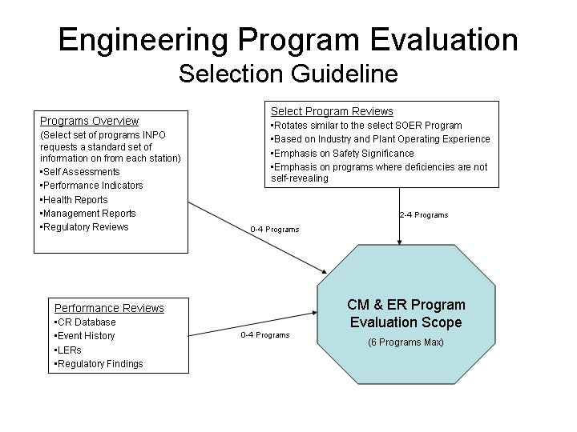
Figure 1

- From the programs overview, select up to four programs that show indications of shortfalls in performance, ownership, and/or oversight.
- Two to four programs will be selected based on industry and/or plant operating experience and safety significance. The selection of these programs may change from plant to plant. The programs selected shall be deemed critical to supporting the equipment reliability and configuration management cross-functional areas. However, shortfalls in these programs may not be self-revealing in the station’s corrective action process or performance indicators. Programs bolded in the Programs Overview section take priority.
- Additional program reviews can be undertaken based on plant performance reviews completed by the Operational Data Analysis Department (ODAD). These programs may be selected due to plant event history, corrective action database or other plant data that may indicate a program shortfall in a particular area.
- Based on the programs selection considerations discussed in steps 1., 2., and 3, the CM and ER Program Evaluation Scope should be finalized. No more than 6 programs (3 equipment reliability related and 3 configuration management related) shall be selected based on limited evaluation resources.
- The final program scope shall be agreed to by the team manager. The team managers may also wish to consult with the appropriate department managers on which programs to select. Following agreement, the list of programs which will receive a detailed review will be communicated to the station in sufficient time such that additional materials needed for review can be requested and received prior to the site visit.
- Existing department How-to’s should be used to perform the more detailed evaluation prior to and during the site visit. For programs without an existing How-to, the generic program evaluation How-to should be used.

